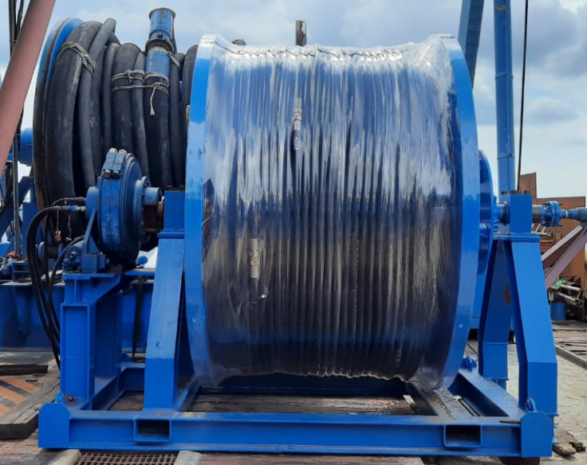

GROUTING SPOOLER
Hose Spooler Specifications
Discharge | 4” and 2” Hammer Union
Swivel Connection | Equipped with 4" chiksan
Motor Model | Hagglunds 6185
Max Torque | 25 Kn.m
Dimensions | 3203 x 2703 x 1030mm x 5tons

Spooler for hose reel is OCS owned asset (Equipment number: OCS-E&M-FSH-001) The supply hose is used to fill Fabric formwork (Grout Bags) with cement from the Hopper Tank on free span rectification projects. After the turn-table is launched and positioned at the desired support location under the pipeline, supply hose will start filing the Grout Bags. During the operation, spooler is to reel up and down the desired size (up to 4”) hose.
Spooler motor is driven by a HPU which has maximum flow of 7.7m³/hr and 3000 psi pressure.

